[**Tableau Server keeps asking for Database Username and password**](https://community.tableau.com/message/495390#495390)

Firstly, the option to embed needs to be enabled on the Tableau Server. Navigate to the Tableau Server > Settings and then ensure there is a check mark in both boxes under Embedded Credentials. This enables a global setting on the Tableau Server.

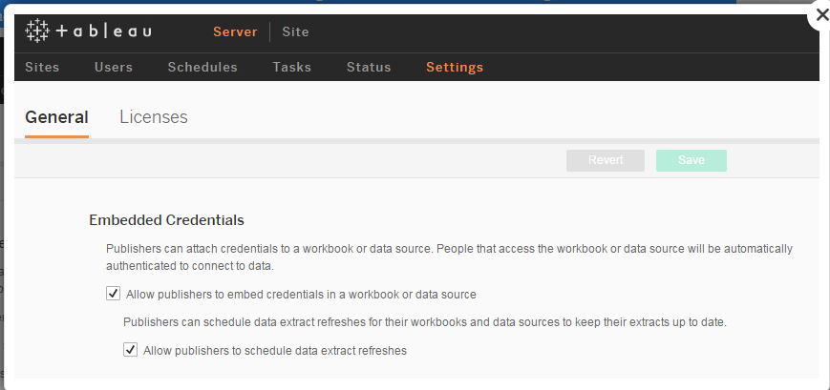

Second, the published data sources need to be told to embed their credentials. In Tableau Desktop, Navigate to Server > Publish Data Source > [selected data source] and then click [Edit] under "Authentication" and change the drop down to "Embedded" then click [Publish].

From there, any workbooks connected to that data source and any extract refreshes triggered by the Tableau Server should not prompt users for their password.